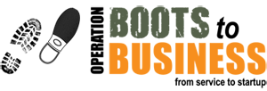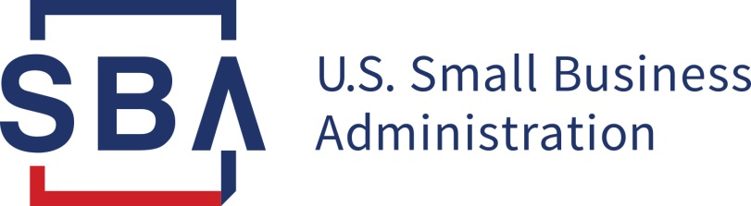

Are you interested in starting your own business?
Please join us for Virtual
Boots to Business
A Free, Two-Day Entrepreneurial Training for Veterans

May 18/19, 2022
8:30 am – 4:00 pm
Online class to register for the training
please use this link:
https://sbavets.force.com/s/
When you get to this link, go to the calendar and select: Online Portsmouth, NS, ME

Offered by the U.S. Small Business Administration (SBA) as part of the Department of Defense.

Boots to Business is a two-step training program developed to introduce Veterans and transitioning service members to business ownership. This 2-day workshop helps ensure that every participant has access to a standardized entrepreneurship training track and the small business resources in their local communities. Any veteran, spouse and/or dependent children over 18 are welcome to participate!

After completing the 2-day Boots to Business session, participants will have the tools and knowledge they need to identify a business opportunity, draft a business plan, connect with local small business resources, and launch their small business. If you have any questions, please contact Miguel Moralez at 603-225-1601 or email miguel.moralez@sba.gov

