NH VETERAN‐FRIENDLY BUSINESS RECOGNITION APPLICATION
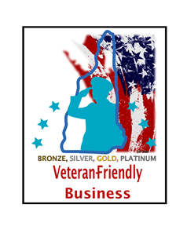
Name of Organization: _______________________________________________________
Address: ___________________________________________________________________
How many NH locations/sites does the business operate? ____________
Type of Business: ___________________________________________________________
Business Phone: ____________________________________________________________
Website Address: ___________________________________________________________

- Person Completing Application—person to be contacted if there are questions about application
Name: _____________________________________________________________________
Contact Info (phone or email): __________________________________________________
- Primary Point of Contact--person will be added to the network email list for all notifications
Name: ______________________________________________________________________
Email: ______________________________________________________________________
- Human Resource Contact--person will receive HR-related notifications such as notices about job fairs
Name: ______________________________________________________________________
Email: ______________________________________________________________________

ELIGIBILITY CRITERIA
Please check the criteria below to confirm the business meets the minimum criteria to be eligible for recognition. All eligibility criteria must be met in order to be eligible for any level of program recognition.
- Business is based in New Hampshire or has locations in the State of NH for which employees are hired
- Business is in good standing with the NH Secretary of State
- Business is not delinquent in paying Unemployment Insurance taxes
- Business is in good standing with the Department of Labor (including Workers’ Comp)
- All required taxes are current with the Department of Revenue
- Business has not had any USERRA violations in the past 24 months

RENEWAL
- Please check if this application is to renew recognition.

For information about the recognition and the types of criteria DMAVS looks for, please refer to the NH Veteran-Friendly Business Recognition Program Info & Roadmap. Refer to the Roadmap for examples on how to recruit, retain, support and serve members of the military and Veteran community.
Recognition will be awarded according to the following table:
Meet the criteria of: | Achieve recognition as a:
Any 1 category | Bronze Business
Any combination of 2 categories | Silver Business
Any combination of 3 categories | Gold Business
All 4 categories | Platinum Business

VETERAN EMPLOYMENT DATA
Please provide the following data to the best of your knowledge from your most recent count. This information will be used by the Department to monitor progress of network initiatives and trends occurring within the network. It will not be used to determine your eligibility for recognition or level of recognition.
Enter #
Number of employees who have served, or are serving, in the military.
Number of employees who have a spouse who has served, or is serving, in the military.
Number of Service members or Veterans hired in the past 12 months.
Number of Service members or Veterans that have left employment in the past 12 months.

HONOR
Businesses that meet the criteria of this category implement strategies, policies and practices that recognize and honor the service and sacrifice of military-connected employees, customers and/or clients/patients. Please describe four (4) ways in which your business HONORS Service Members, Veterans and their Families. For examples, refer to the NH Veteran-Friendly Business Recognition Roadmap.
4 examples required

FORTIFY
Businesses that meet the criteria of this category implement strategies, policies and practices aimed at fortifying the family units of Service members, Veterans and their family members by hiring, preparing them for successful employment and ensuring quality of life needs are met. Please describe three (3) ways in which your business FORTIFIES Service Members, Veterans and their Families. For examples, refer to the NH Veteran-Friendly Business Recognition Program Info & Roadmap.
3 examples required

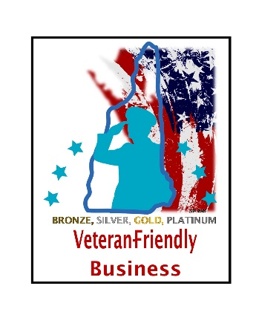
EMPOWER
Businesses that meet the criteria of this category implement strategies, policies and practices aimed at EMPOWERING Service members, Veterans and their family members through opportunities for career and/or personal development. Please describe three (3) ways in which your business EMPOWERS Service Members, Veterans and their Families. For examples, refer to the NH Veteran-Friendly Business Recognition Program Info & Roadmap.
3 examples required

IMPACT
Businesses that meet the criteria of this category implement strategies, policies and practices aimed at making a positive IMPACT in the lives of Service members, Veterans and their Families as experienced outside of work and in their New Hampshire communities. Please describe two (2) ways in which your business IMPACTS Service Members, Veterans and their Families. For examples, refer to the NH Veteran-Friendly Business Recognition Program Info & Roadmap.
2 examples required

WEBSITE--SPOTLIGHT
All NH Veteran-Friendly Businesses will be spotlighted on the Department of Military Affairs & Veterans Services website. Please provide a description of the business for posting on the DMAVS website. Include ways in which it is “veteran-friendly” as viewers of the page are likely to be military-connected. Include links to your business website or recruiting page.
Length: 300 word limit

WEBSITE--LOGO
In addition to a description of your business, a logo can be placed alongside your description. Please send a logo along with your application for use on the DMAVS website. The submission of the logo with the application will indicate your permission for DMAVS to use the logo alongside your business name and description the Department of Military Affairs & Veterans Services website. If a logo is not submitted with the application, only the name of the business and the description provided will be shown on the website.
Recommended technical requirements: low-res for use on web; .PNG format; recommended between 250 x 100px and 400px X 100px for a horizontal logo, and 160px X 160 px for a vertical logo

SUBMIT APPLICATION & DEADLINES
Submit your application and business logo to the Department of Military Affairs & Veterans Services via email.
VeteranFriendlyBusiness@dmavs.nh.gov
Applications are accepted and reviewed on a quarterly basis year-round. Recognition will be awarded for a period of 2 years, then businesses will need to re‐apply. Quarterly deadlines: March 31, June 30, September 30, December 31.

